Date:  Our reference:  Email: | 18 August 2020  NoF/HSS05/MJ  Healthy.school.streets@camden.gov.uk

Transport Strategy
Supporting Communities
London Borough of Camden
Town Hall
Judd Street
LONDON
WC1H 9JE
Phone: 020 7974 5537
camden.gov.uk

Addressee
Address Line 1
Address Line 2
Address Line 3
TOWN
Postcode

Dear Resident/Group/School/Business

We are writing to update you on the Neighbourhoods of the Future “Healthy Schools Street” zone project area. This letter follows the previous update letter sent to you at the beginning of July.

The aim was to implement the scheme at the beginning of September, in time for the new academic year. However, due to some technical issues, this is now likely to be 14 September 2020. It will mean restricted access to the area for non-residents. The timings will be from 8am to 9am and 3pm to 4.15pm Monday to Friday during school term time only. This will be enforced using Automatic Number Plate Recognition (ANPR) cameras. Folding signs stating the times will be used to alert drivers, these will be closed during school holidays. The restricted area will be on the following roads:

Netherhall Gardens from the junction with Fitzjohn’s Avenue to the Finchley Road junction.
Netherhall Way.
Maresfield Gardens and Nutley Terrace from the junctions with Fitzjohn’s Avenue.
Frognal from the junction with Arkwright Road, up to but not including Hampstead Gate.

Exemptions

The restrictions will be enforced by ANPR cameras, and exemptions for the following vehicles will be given:

- Blue Disabled Badge holders (BDB) resident in the restricted areas. Please apply for an exemption.
- BDB holders who need to visit a business or residential property within the restricted zone. Please apply for an exemption.
- Emergency Services vehicles responding to an emergency.
- Residents vehicles registered in any of the restricted roads listed above (see the streets marked in red on the below restricted zone plan). Please apply for an exemption.
- Residents vehicles registered to properties in any of the restricted roads (as above) that have off street parking, or a ‘crossover’ to their driveway. Please apply for an exemption.
- Children with disabilities that prevent them from walking, scooting or cycling to school – the vehicles which pick them up/drop them off will be exempt. Parents/carers must apply for an exemption.
- Pure Electric Vehicles (not hybrids) – including those used for Private Hire Vehicles (PHVs)
- Zero Emission Capable taxis (“black cabs”)
- Elderly/disabled residents requiring taxis for hospital appointments etc. These will be assessed on a case by case basis. If you require this, please contact us via the e-form on the website: https://www.camden.gov.uk/healthy-school-streets, or via the address/phone/email on this letter at least 5 days before the exemption is needed.
Applying for an exemption

If you require an exemption for any of the above circumstances, please apply to register your vehicle, using one of the following methods:

- Use the online form here (Neighbourhoods of the Future Exemptions Form): https://www.camden.gov.uk/healthy-school-streets
- Email: healthy.school.streets@camden.gov.uk
- Phone: 020 7974 1391
Restricted zone

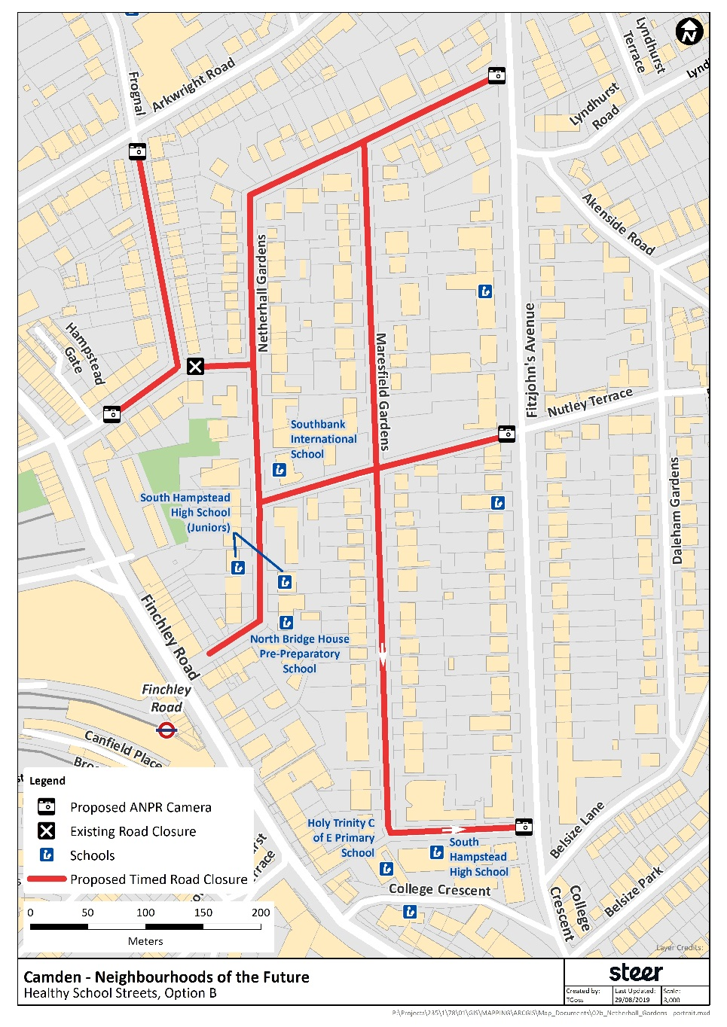

The scheme is being implemented under an Experimental Traffic Order (ETO) for a year, during which time traffic levels will be monitored, along with pupil travel modes before and after implementation. Feedback can also be sent to the Council during the ETO period via the email address at the top of this letter. Air quality measuring equipment is in place in the zone, however during the COVID-19 lockdown, it has not been possible to administer this. Therefore, officers may not be able to report on the air quality data for every month before and after implementation.

The ETO will be advertised on 27 August 2020.

If you would like any further information regarding this scheme, please contact the team on the details at the top of this letter.

Yours Sincerely

Camden Healthy School Streets Team

